
CRANE'S CAPE TOURS & TRAVEL
P.O.BOX 26277 * HOUT BAY * 7872
CAPE TOWN * SOUTH AFRICA
TEL: / FAX: (021) 790 0616
CELL: 083 65 99 777
E-Mail: birdtour@hbic.co.za
www.naturalhistorytours.co.za

This is one of several sample itineraries available on www.honeyguide.co.uk/yoursouthafrica.htm run by Crane’s Cape Tours and Travel with Honeyguide Wildlife Holidays. We can also adapt itineraries to suit you – please contact us so together we can plan your South African wildlife holiday.

Kgalagadi Transfrontier Park and the Augrabies Falls National Park

Days 1 to 9.
Upington / Twee Rivieren camp - 5 nights / Nossop camp – 3 nights
The Kalahari National Park, recently renamed the Kgalagadi Transfrontier Park, is a chance to see one of the last true wilderness reserves in the world. The park covers an area of over 3.6 million hectares and extends into three countries: South Africa, Namibia & Botswana, with no border or boundary fences. Over 60 mammal species call the Kgalagadi their home. Kalahari lion, cheetah, leopard, African wild cat, gemsbok, springbok and many other mammal species can be seen in the park. The park is characterised by its red sand dunes with sparse vegetation and the dry riverbeds of the Nossob and Auob rivers, where camel thorn, raisin bush and black thorn attract over 215 bird species to their welcoming cool shade. Reptile species almost out number the mammal species, with ground agama and barking geckos being common in the camps.

While in the park, we usually start the day with the birds at sunrise, for a two hour local drive, followed by breakfast and then another longer drive before retiring to the camp to escape the midday sun! At about 3 p.m. we can venture out on an afternoon drive. The camps are large enough to walk around on a natural history walk. Veld walks, sunset drives and night drives are also offered by the National Park rangers.

Nossob Camp has basic facilities and our culinary expertise will be tested, as there is no restaurant to look after us! This area is seldom visited and has a reputation for excellent lion, leopard and cheetah sightings. The Nossop camp has a lovely bird hide overlooking the water hole, as well as a few resident Owls. The night drives with a specialist guide can be very rewarding, not only for the big cats but also for brown hyaena, honey badger, owls, nightjars and dikkops.

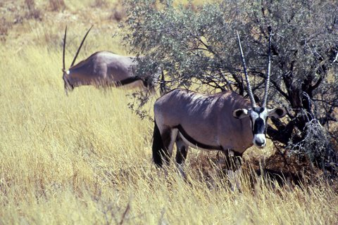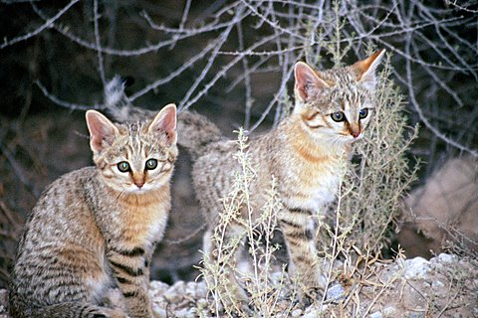
Left: gemsbok. Right: African wild cat kittens

Days 9 to 14
Augrabies Falls National Park – 5 nights
We will leave the Kgalagadi Transfrontier Park after breakfast and head for Augrabies Falls National Park. Here the mighty Orange River drops into a deep and spectacular 56 metre gorge, aptly named by the Khoi as ‘place of great noise’. The Augrabies Falls National Park has many bird species that include the pygmy falcon, rosy-faced lovebird, cinnamon-breasted warbler, many chats and larks, as well as the magnificent Verreaux’s eagle, martial eagle and Ludwig’s bustard. There are also many mammal species that can be seen on the numerous walks and trails within the Park.

We will be walking a number of the trails looking out for plants, mammals and birds within the strikingly beautiful lunar landscape of the Park. The abstract, arid landscape, with its weathered rocks and trees make this park a photographer’s dream. Birdwatching can be very rewarding from the restaurant deck, as the birds are attracted by the possibility of a few restaurant titbits. Beer in one hand binoculars in the other ... this could be many birdwatchers idea of paradise!

We will drive back to Upington for your return flight to either Cape Town or Johannesburg. Alternatively, you may like to spend a few extra days driving back through the Great Karoo to Cape Town.

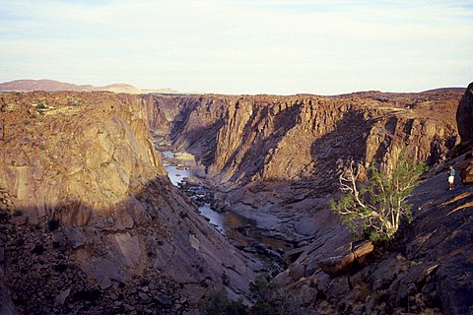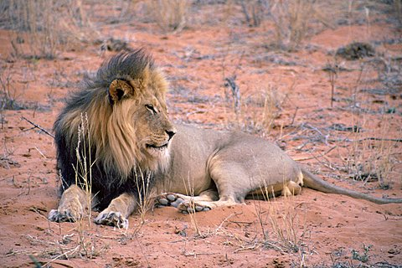
Left: Augrabies Falls National Park. Right: Kalahari lion

When to visit: any time of year, but September / October is best

