
CRANE'S CAPE TOURS & TRAVEL

P.O.BOX 26277 * HOUT BAY * 7872
CAPE TOWN * SOUTH AFRICA

TEL: / FAX: (021) 790 0616

CELL: 083 65 99 777

E-Mail: birdtour@hbic.co.za
www.naturalhistorytours.co.za

This is one of several sample itineraries available on www.honeyguide.co.uk/yoursouthafrica.htm run by Crane’s Cape Tours and Travel with Honeyguide Wildlife Holidays. We can also adapt itineraries to suit you – please contact us so together we can plan your South African wildlife holiday.

St Lucia & Zululand and the Drakensberg Mountains

Days 1 to 9. St Lucia & Zululand – 8 nights
The village of St Lucia on the Indian Ocean coastline is an ideal base, surrounded by forests, beaches, an estuary and many sights of interest. We will enjoy guided walking trails, birding and botanizing all the way. Boat trips, 4x4 game drives and cultural tours are all accessible from St Lucia.

Cape Vidal is a small coastal resort set in a sheltered bay in the Greater St Lucia Wetland Park, with shallow pools and rock ledges for snorkeling, unspoiled beaches for walking or relaxing and self-guided walking trails around the fascinating wetlands, in the rich coastal forest and on the shores of Lake Bhangazi. Wildlife, especially birds, is abundant on the walking trails. While Loggerhead and leatherback turtles come onto the beaches to lay their eggs (in summer) and whales can be seen on their northerly migration to Mozambique to calve.
Hluhluwe-Imfolozi Game Reserve (pronounced ‘Shlu-shlu-wie’) was established in 1895 and is the oldest game park in Africa. The wide range of plant life in the park gives rise to a diversity of mammals, birdlife, reptiles and amphibians. The Big Five - lion, rhino (black & white), elephant, buffalo and leopard - are all to be seen, as well as Nile crocodile, hippo, cheetah, hyena, blue wildebeest, jackal, giraffe, zebra, waterbuck, nyala, eland, kudu, impala, duiker, suni, reedbuck, warthog, bushpig, mongoose, baboons, monkeys and a variety of tortoises, terrapins, snakes and lizards. In excess of 300 species of birds have been recorded. The variety of habitats within the park is one of the reasons why it is one of the prime birding destinations in South Africa. The Hluhluwe River Flood Plain is one of the favored birding spots.
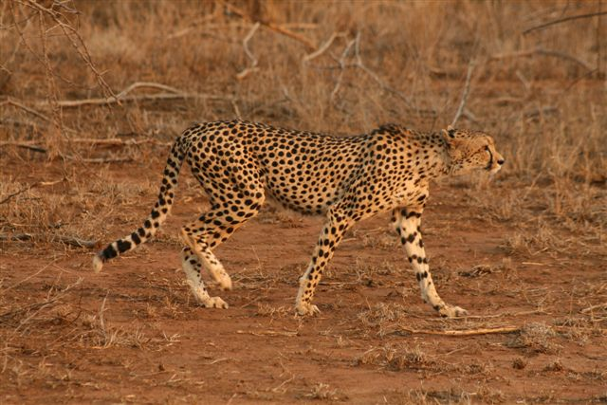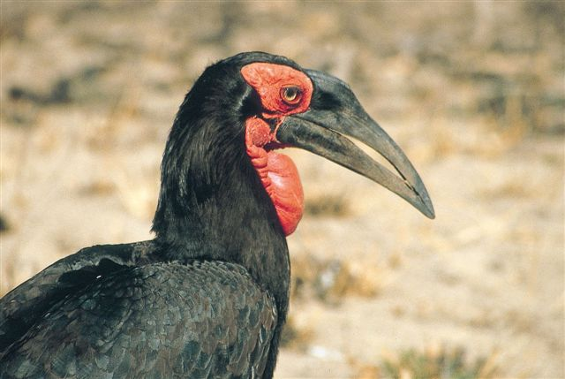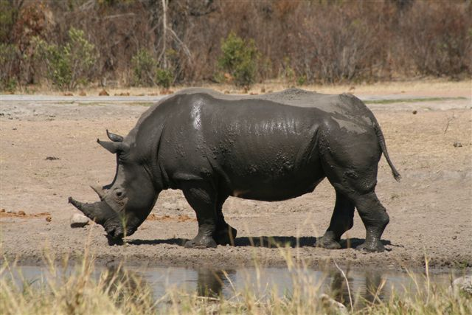
Cheetah, ground hornbill and white rhino
The St Lucia Wetland Park, recently named the iSimangaliso Wetland Park, offers ecotourists some of the most diverse wildlife and outdoor experiences imaginable. A boat cruise on the lake is the most comfortable way to see the area! While birding on one of the many trails will be well rewarded. The Park has many mammals, hippo, rhino, elephant, buffalo, giraffe, waterbuck, kudu, nyala, impala, duiker and reedbuck as well as a host of other species. Also many reptile species, the Nile crocodile being the biggest.
The Forest Aerial Boardwalk at Eshowe offers a new perspective on the forest. The 125m walkway, which takes visitors from the forest understory into its leafy canopy giving a close glimpse of life high above the forest floor - birds nesting and feeding, epiphytic orchids flowering in dappled light and giant trees competing for light and space. At the end of the walkway, visitors can climb the 20m-high viewing tower which emerges above the canopy of the trees and has magnificent views over the forest and of the countryside leading down to the coast. We will also take a guided birding walk through the forest, with its fern-covered glades and rich diversity of birdlife.

Days 9 to 14. Drakensberg Mountains - 5 nights
The Royal Natal National Park is situated below the sheer face of the Drakensberg escarpment. The land comprising this National Park ranges from approximately 1500 to 3000 meters in altitude. There are many hiking trails of varying length and gradient that will take us into the Amphitheatre, the most magnificent of all the Drakensberg mountain scenery. The deep valleys that are overlooked by mountain grasslands and rugged peaks, support protea stands and indigenous woodlands, which play host to a variety of birds and mammals. Our stay in the Drakensberg will be characterized by short walks, botanizing and birding, with the option to do some more strenuous walks in to the deep gorges at the base of the escarpment.

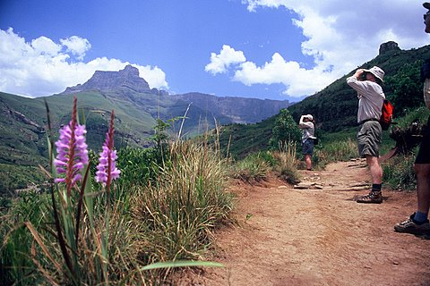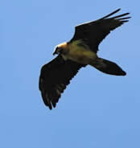
Drakensberg Mountains and lammergeier

When to visit: any time of year, but September to March is best.

